 | April 24  6:30—8:00 PM  Prescott College  Crossroads Center | 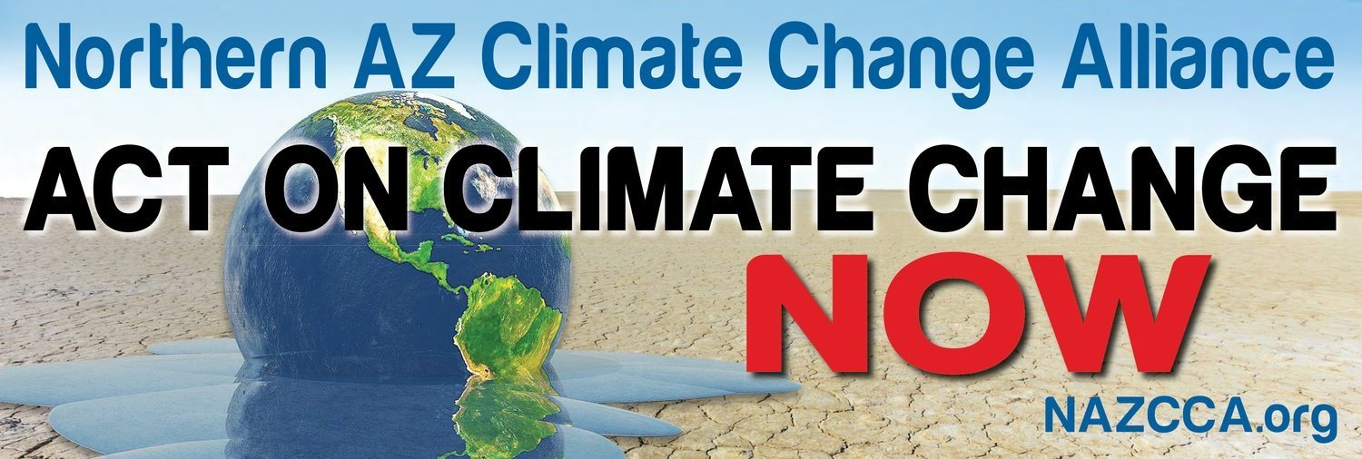

Energy Choice in Arizona program
Arizona’s monopoly investor-owned utility model (IOU) is failing to give us low-cost renewable energy and protect consumer wallets. Shelly Gordon, director of Arizonans for Community Choice, will discuss IOU and other models (such as Community Choice Energy) that lower costs, offer more renewable energy, and focus on community and ratepayer needs. She will describe initiatives aimed at promoting competition and choice— especially those of the City of Tucson. David Spence, NAZCCA member and Flagstaff City Councilman—after telling us his own compelling story—will describe his area’s sustainability and clean energy efforts. The program will begin with a short talk by Stephen Cook— Sierra Club Yavapai Group Vice-Chair and “think globally, act locally” advocate. And end with a panel composed of Cook / Spence / Gordon fielding questions.

April 24
6:30—8:00 PM
Prescott College
Crossroads Center

Energy Choice in Arizona program
Arizona’s monopoly investor-owned utility model (IOU) is failing to give us low-cost renewable energy and protect consumer wallets. Shelly Gordon, director of Arizonans for Community Choice, will discuss IOU and other models (such as Community Choice Energy) that lower costs, offer more renewable energy, and focus on community and ratepayer needs. She will describe initiatives aimed at promoting competition and choice— especially those of the City of Tucson. David Spence, NAZCCA member and Flagstaff City Councilman—after telling us his own compelling story—will describe his area’s sustainability and clean energy efforts. The program will begin with a short talk by Stephen Cook— Sierra Club Yavapai Group Vice-Chair and “think globally, act locally” advocate. And end with a panel composed of Cook / Spence / Gordon fielding questions.

April 24
6:30—8:00 PM
Prescott College
Crossroads Center

Energy Choice in Arizona program
Arizona’s monopoly investor-owned utility model (IOU) is failing to give us low-cost renewable energy and protect consumer wallets. Shelly Gordon, director of Arizonans for Community Choice, will discuss IOU and other models (such as Community Choice Energy) that lower costs, offer more renewable energy, and focus on community and ratepayer needs. She will describe initiatives aimed at promoting competition and choice— especially those of the City of Tucson. David Spence, NAZCCA member and Flagstaff City Councilman—after telling us his own compelling story—will describe his area’s sustainability and clean energy efforts. The program will begin with a short talk by Stephen Cook— Sierra Club Yavapai Group Vice-Chair and “think globally, act locally” advocate. And end with a panel composed of Cook / Spence / Gordon fielding questions.

